Neurosurgery

|  |  |  |  |  |  |
| --- | --- | --- | --- | --- | --- |
| First Name |  | Last Name | Gender |  | Doctor’s Degree |
| Knox |  | Thaddeus | M |  | Doctoral |
| Hayfa |  | Walker | F |  | Bachelor |
| Talon |  | Baxter | M |  | Bachelor |

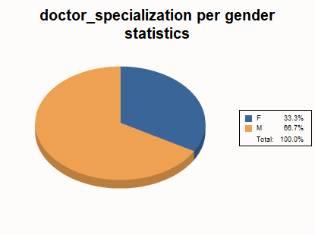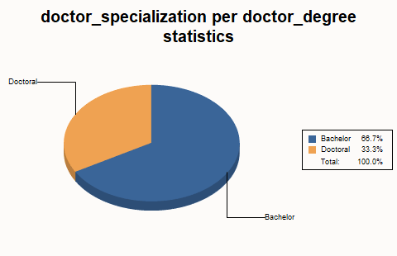

Radiation oncology

|  |  |  |  |  |
| --- | --- | --- | --- | --- |
| First Name | Last Name | Gender |  | Doctor’s Degree |
| Colorado | Owen | M |  | Master |
| Levi | Reuben | M |  | Bachelor |
| Geraldine | Gannon | F |  | Master |

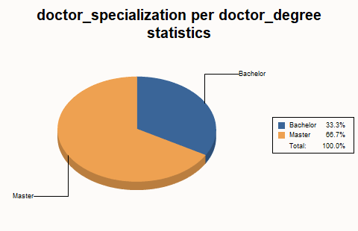

|  |  |  |  |
| --- | --- | --- | --- |
| Ori | Grady | F | Bachelor |
| Chava | Yuli | M | Bachelor |

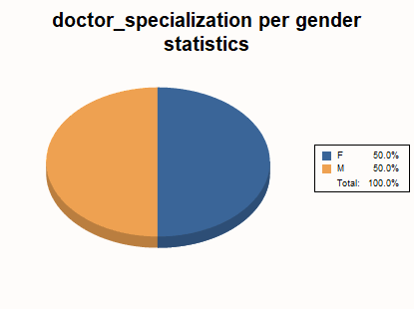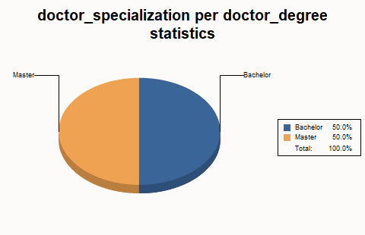Thoracic Surgey

|  |  |  |  |  |  |
| --- | --- | --- | --- | --- | --- |
| First Name | Last Name |  | Gender |  | Doctor’s Degree |
| Jeanette | Upton |  | M |  | Master |
| Steven | Austin |  | F |  | Master |